WORK 8

***Trending Towards Tapestry / Herring* – APU exhibit**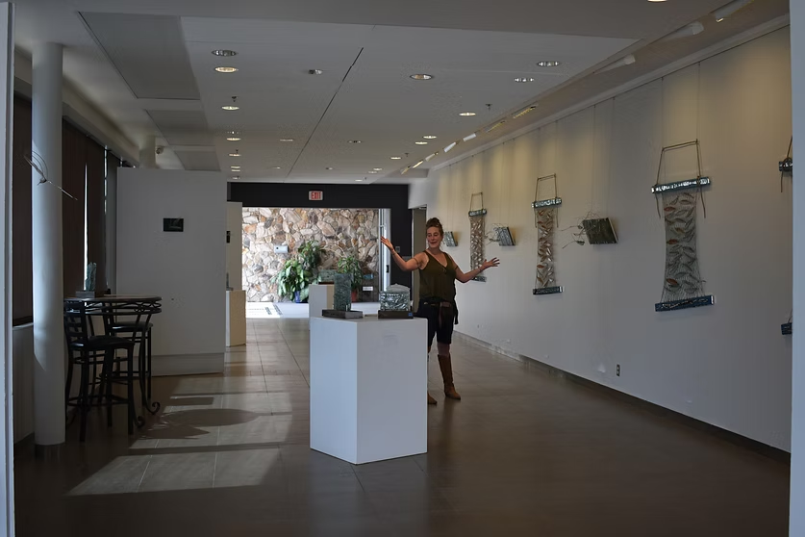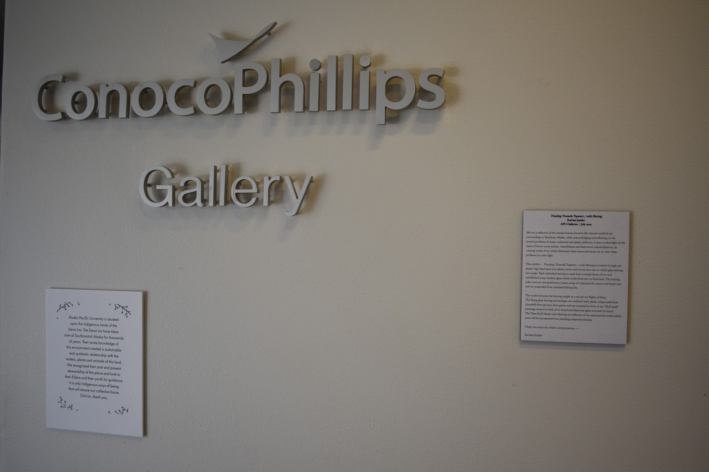

***Trending Towards Tapestry / with Herring***

**Rachael Juzeler**

**APU Galleries | July 2022**

My art is reflective of the intense beauty found in the natural world of my surroundings in Southeast Alaska, while acknowledging and reflecting on the

societal problems of waste, industrial and plastic pollution. I want to shed light on the issues of throw away society, wastefulness and destructive industrialization, by creating works of art which illuminate these issues and cause one to view these problems in a new light.

This exhibit – *Trending Towards Tapestry / with Herring* is created of single use plastic bags hand spun into plastic twine and woven into nets in which glass herring are caught. Each individual herring is made from multiple layers of cut and embellished scrap window glass which is kiln fired into its final form. The herring laden nets are strung between mosaic strips of reclaimed tile, mirror and beach rust and are suspended from reclaimed fishing line.

The works between the herring caught in a net are my flights of fancy.

The flying glass herring and hooligan are outfitted with plastic wings made from clamshells from grocery store greens and are mounted in front of my “H2O quilt” paintings created in both oil on board and kilned art glass mounted on board.

The Glass H2O blocks with Herring are reflective of my experimental works which soon will be incorporated into standing sculptural columns.

I hope you enjoy my artistic interpretations —-

*Rachael Juzeler*

